** PROMKET**

**OIL AND GAS CONSULT NIGERIA LIMITED**

**Vision Statement**

To be a world class Consultancy Company in Petrochemical and environmental management.

**Mission Statement**

To carry out world class research for the advancement and development of local content in Nigeria, ensure high quality service, sound environmental management and application of standard laboratory practice. The operations of the company would be at all times supported by professionally experienced and qualified engineers and technicians to ensure job safety to personnel and environment.

**PROMKET Petrochemical and Environmental Laboratory**

**Available equipment in the Laboratory:**

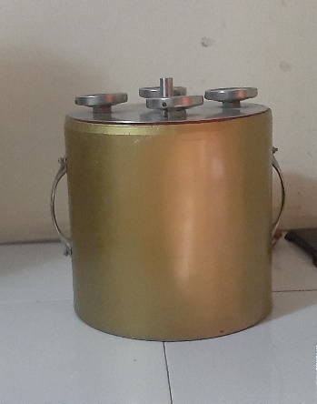

**Pour Point Determination** **equipment**

Pour point determination equipment can be used to determine the pour point of waxy crude oil.

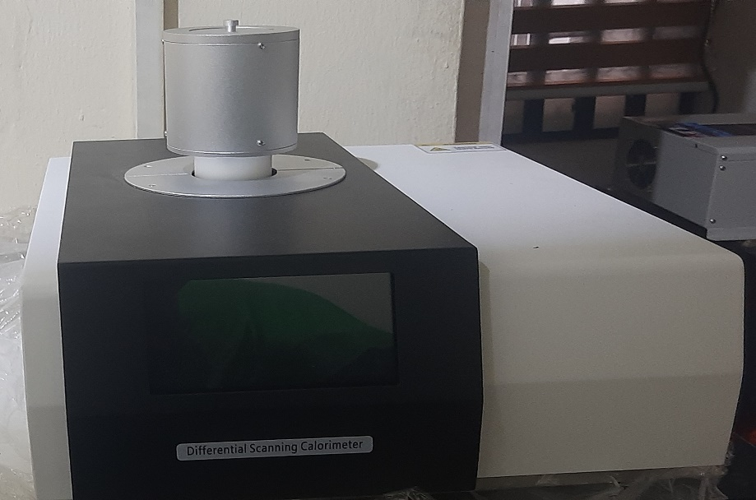

**Differential Scanning Calorimeter 800**

Differential scanning calorimeter (DSC 800) can be used to determine the following properties of materials:

* Cold crystallization, phase transition, melting, crystallization, product stability, curing reaction temperature, thermal effect measurement.

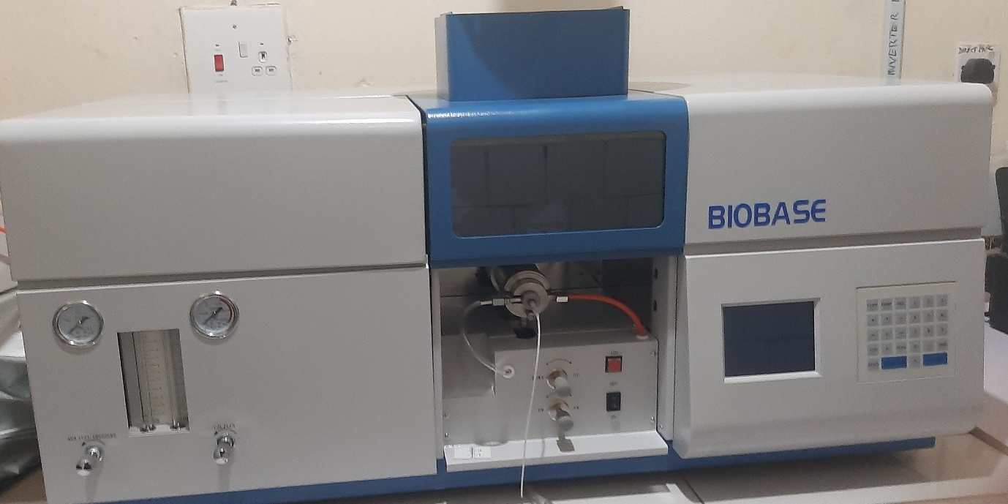

**Atomic Absorption Spectrometer (AA320N)**

Atomic Absorption spectrometer (AA320N) can be used to determine the following heavy metals in produced or potable water samples:

* Sodium (Na), Magnesium ( Mg), Calcium (Ca), Iron (Fe), Lead (Pb), Chromium (Cr), Barium (Ba), Mercury ( Hg), Copper (Cu).

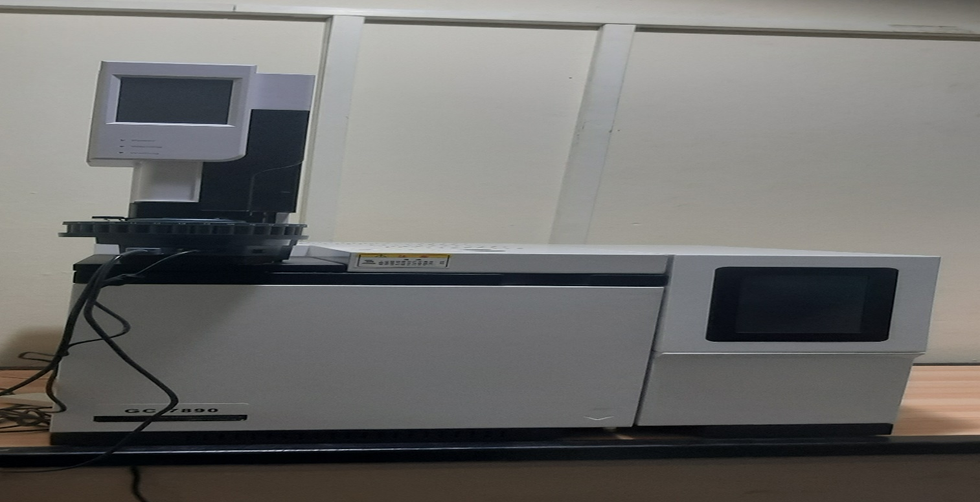

**Gas chromatography (GC- 7890)**

Gas chromatography (GC-7890) can be used to determine the following:

* Speciated Total Petroleum Hydrocarbon (STPH) C8-C40
* Total Petroleum Hydrocarbon (TPH)
* Paraffinic crude oil wax content

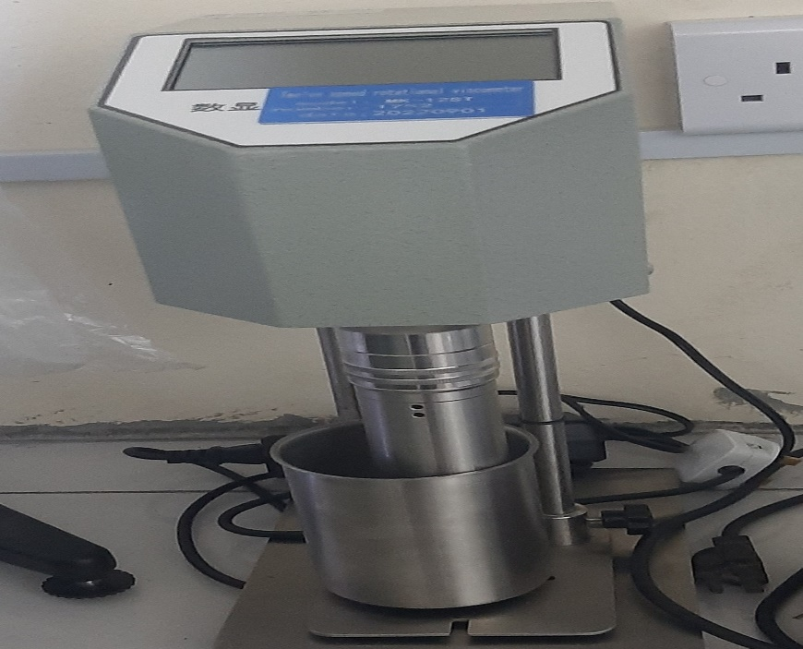

**Twelve (12) Speed Rotary Viscometer**

Twelve (12) speed rotary viscometer can be used to test the rheology of petroleum, chemical, medicine, cosmetics and other industry and research liquids.

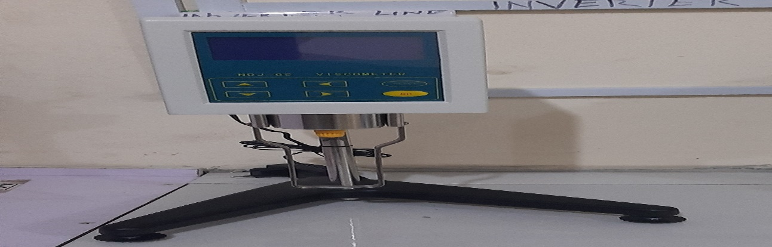

**NDJ- 8S Digital Rotary Viscometer**

NDJ- 8S Digital rotary viscometer can be used to determine and measure liquid viscosity in many applications such as grease, paint, pharmacy and adhesive.

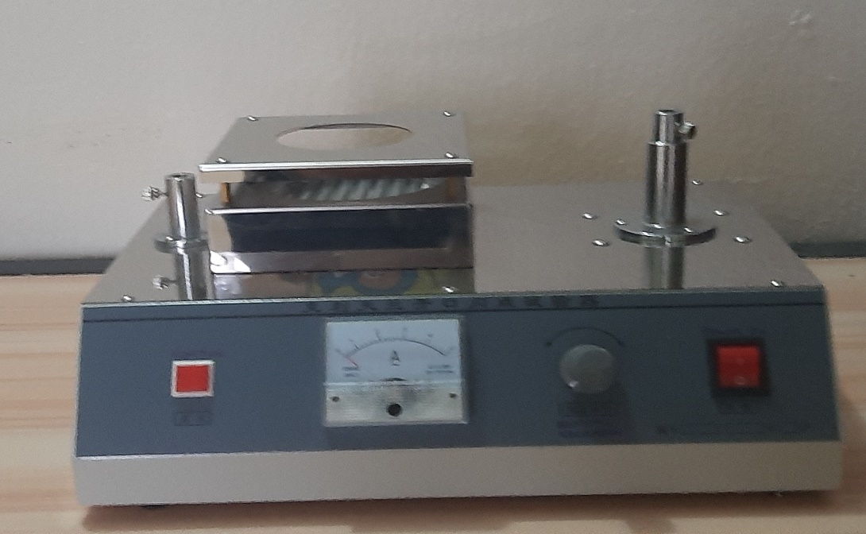

**Flash Point and Ignition Point Analyser**

The flash point analyser can be used to determine the ignition temperature of volatile substance.

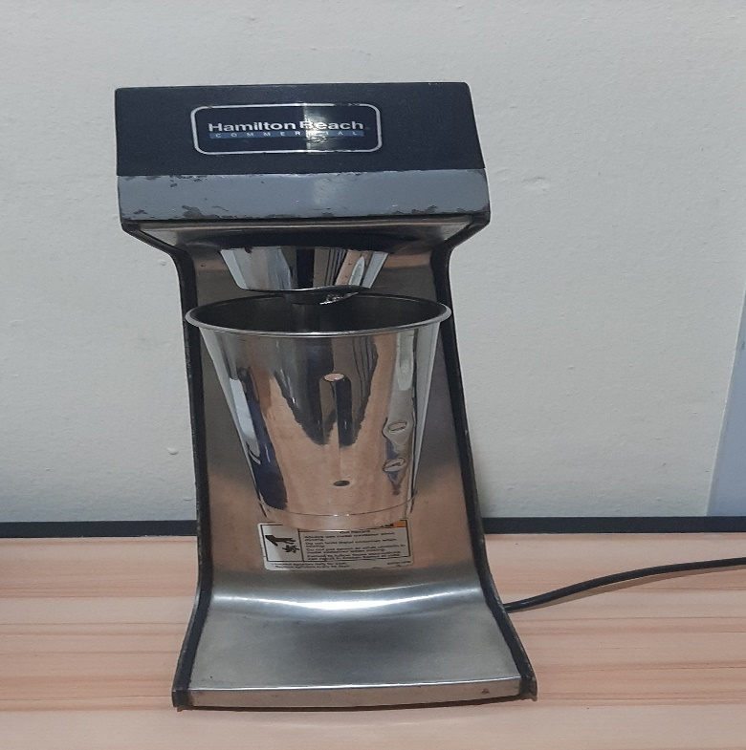

**Hamilton Beach mixer**

Hamilton beach mixer can be used to mix mud samples with additives at given designed proportion to ascertain its effect on the rheological properties of drilling mud.

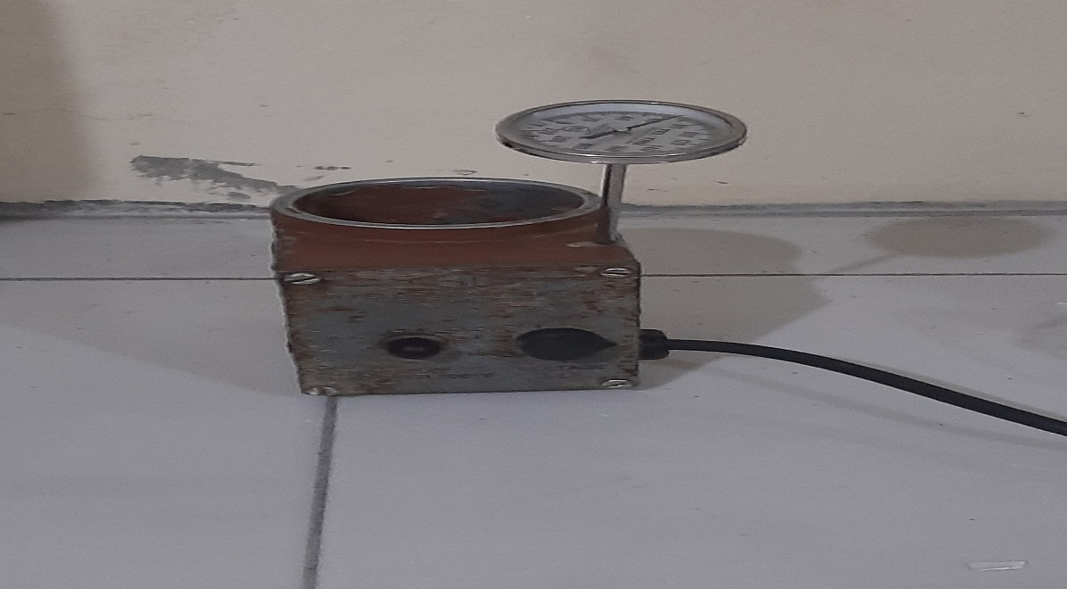

**Thermo Cup**

The thermo cup can be used to determine the effect of varying temperature

on the rheological property of drilling mud or hydrocarbon.

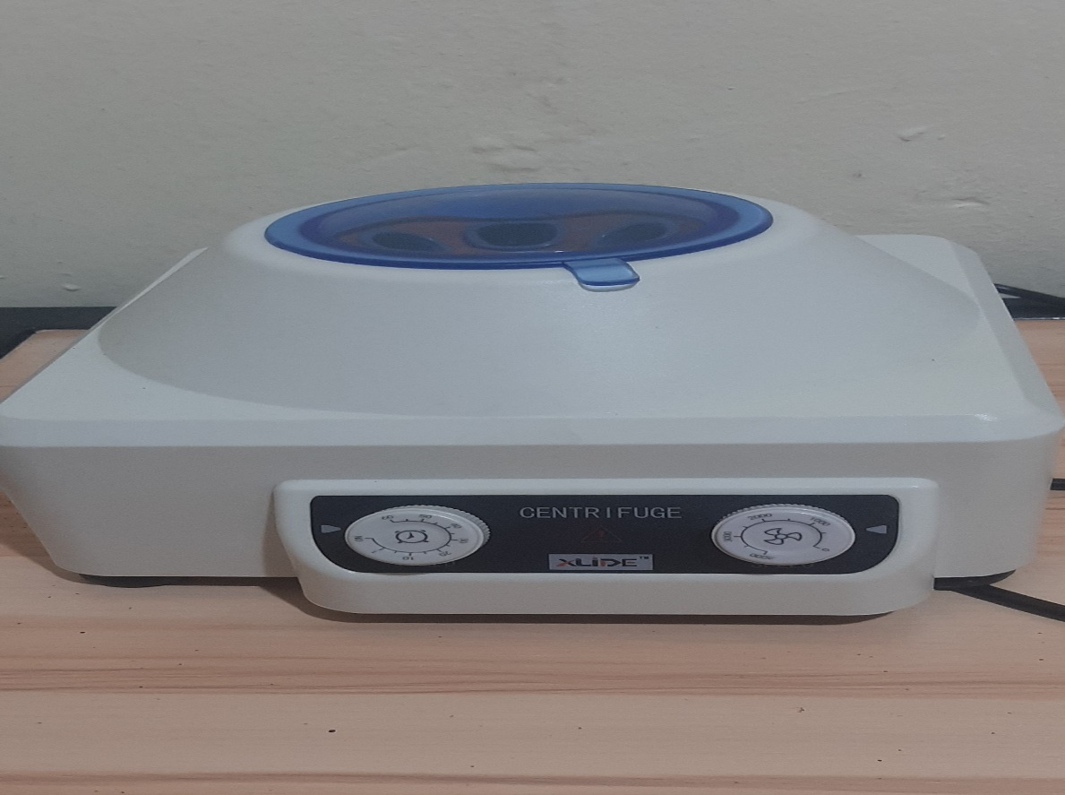

**Centrifuge machine**

Centrifuge machine is used to separate substances based on their differential densities**.**

It can be used to determine the Base Sediment and water (BS&W) of crude oil

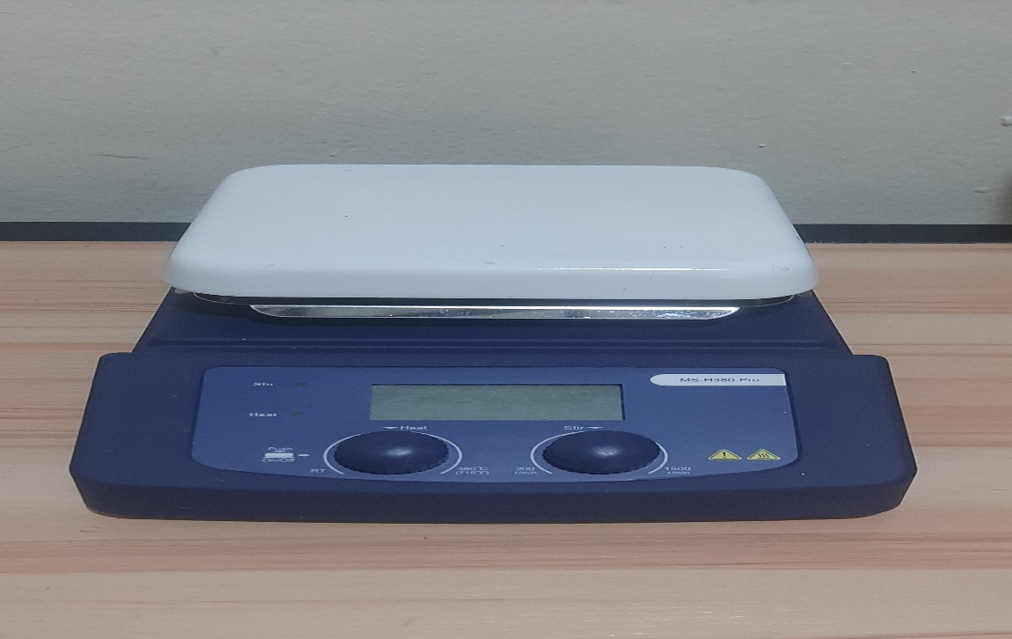

**Magnetic Stirrer**

**Magnetic stirrer can be used to mix solvents or reagents to form an homogeneous solution.**

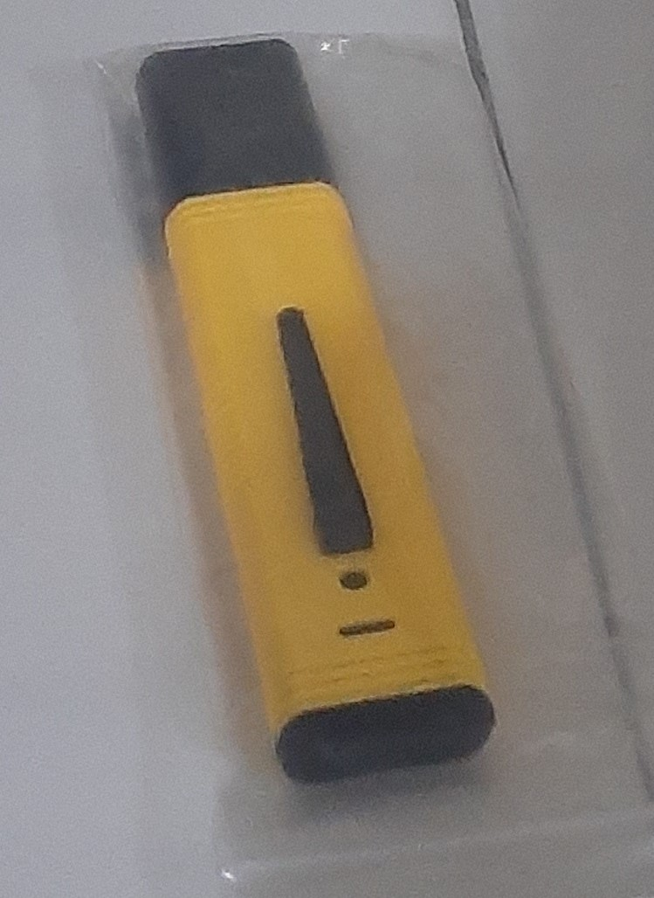

**pH meter**

**The pH meter is used to determine the pH of liquid**

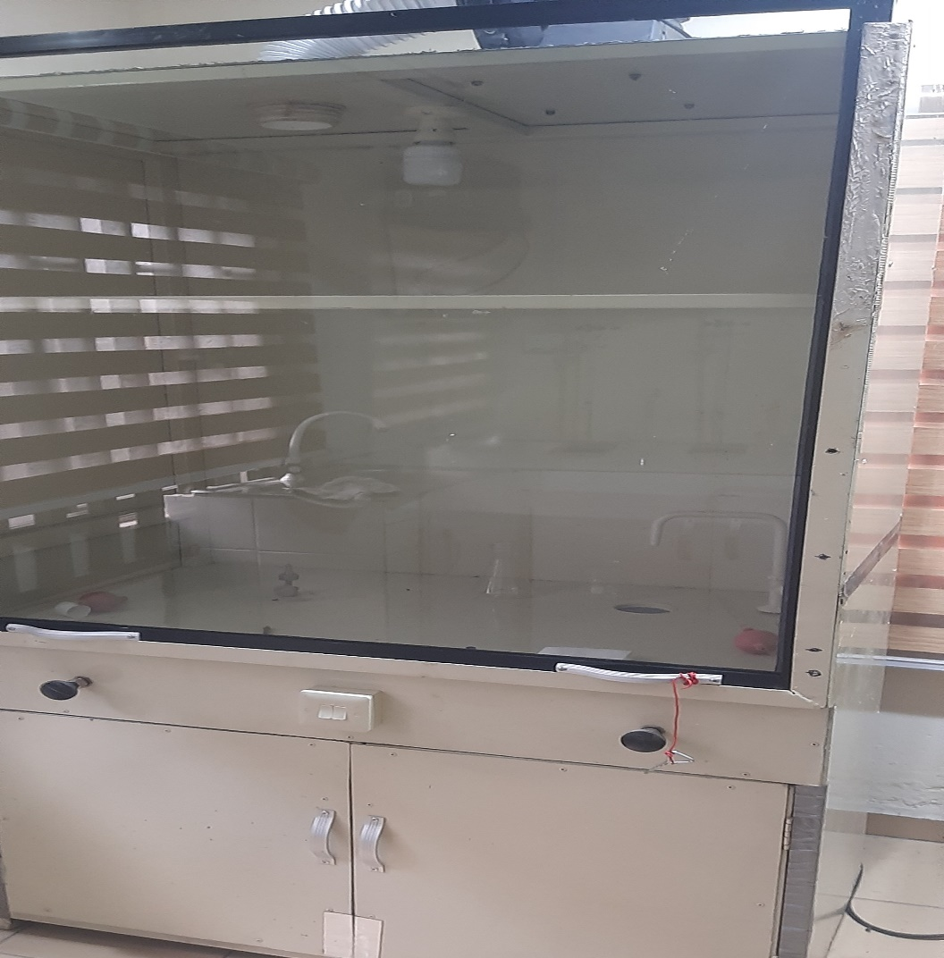

**Fume cupboard**

**Fume cupboard is used for sample preparation to prevent inhaling toxic fumes or gas that is got rid- off with the aid of an air expeller**

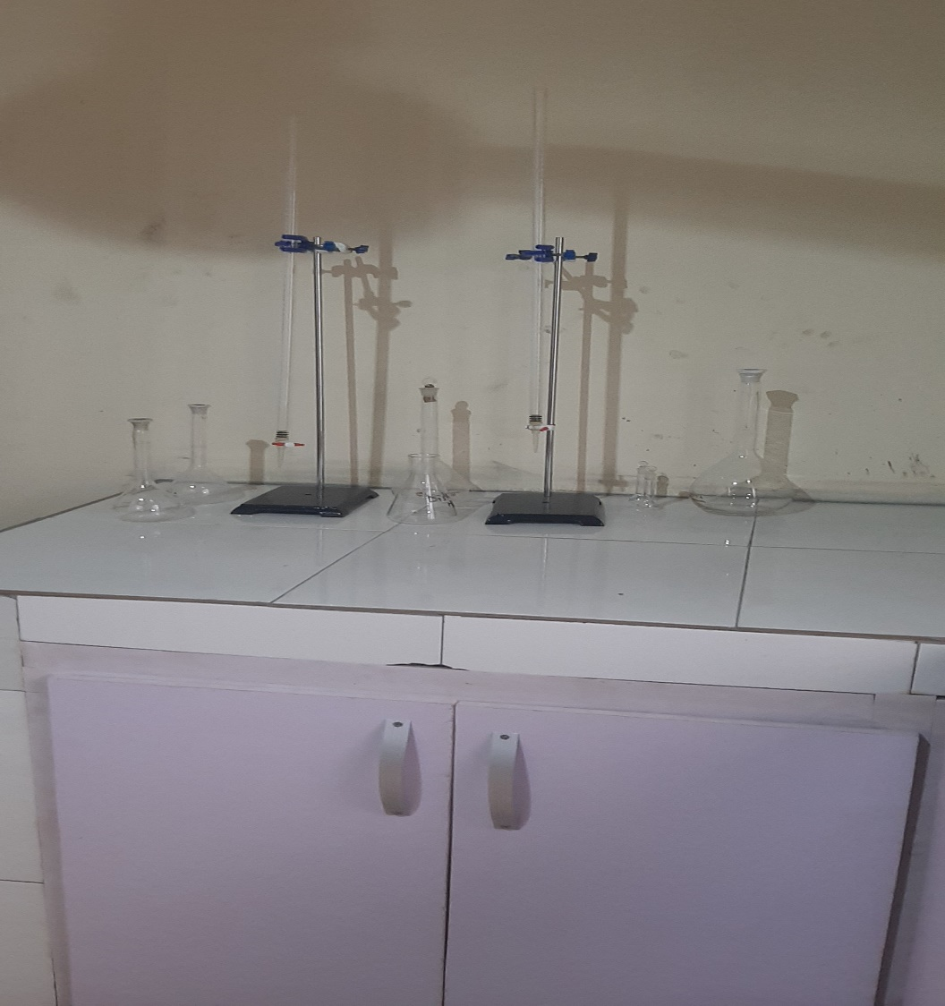

**Wet chemistry concrete table and apparatus**

**The wet chemistry concrete table and apparatus is used to conduct wet chemistry chemical analysis**

**PHYSICOCHEMICAL ANALYSES CARRIED OUT**

1. Water analysis
2. Soil analysis
3. Oil extraction
4. Oil characterization
5. Physical appearance
6. Colour
7. Odour
8. pH
9. Specific gravity
10. Electrical conductivity
11. Dissolved oxygen
12. Total suspended solids
13. Total dissolved solids
14. Total solids
15. Chloride
16. Salinity
17. Alkalinity
18. Total organic carbon
19. Total carbon
20. Arsh content
21. Ammonium content
22. Phosphorus
23. Phosphate
24. Nitrate
25. Nitrite
26. Sulphate
27. Sulphide
28. PAH
29. TPH
30. Heavy metals
31. Indicated and specific gravity
32. Viscosity @40
33. Viscosity @60
34. Viscosity @100
35. Viscosity index
36. Rheology
37. Pour point
38. Flash point

**DPR Permits obtained:**

1. **Laboratory services** – Chemical and mud testing
2. **Onshore environmental / waste management** – Environmental assessment / studies (EIA, EER, EAR, PIA)
3. **Training**

**PROMKET**  Training

* Basic and advance crude oil and gas Production Operations
* Basic and advance crude oil and gas drilling Operations
* Basic and advance crude oil and gas reservoir Operations
* Oil field chemical applications
* Basic wellhead and production platform instrumentation
* Laboratory Safety & Safe Chemical Handling.
* Basic introduction to statistics
* Advance statistics and application
* Learning the fundamentals of python
* Machine learning algorithms

**PROMKET** Consulting

* Flow assurance
* Production operations
* Drilling operations
* Petroleum reservoir operations
* Environmental

e-mail: [promketconsultltd@gmail.com](mailto:promketconsultltd@gmail.com)

promketconsultlab@gmail.com

For further enquiry call **08039230721/08027661375**

Location: 72A Aliaparanwo Road, Obio Akpor L.G.A.

Rivers State, Nigeria.